Mini Racer

Subject:  Related Subjects: | Grade Level(s):  Length of Lesson: | Type: Inquiry / Design / Project  Keywords:

Lesson Overview
Use this section to describe at a high level what the lesson is. Should be no more than 3-4 lines.

Lesson Focus
What is the central question or phenomenon being investigated? What problem are they trying to solve?

Lesson Objective(s) | - To build a mini racer with given materials to be launched for greatest straight-line distance from the launching point.  - Students will be given 40 minutes to build mini racer. Launching of mini racers will be at 40 past the hour for each session.

Lesson Timing

5 minutes | Introduce the Lesson
30 minutes | ...

Materials | - Per Group:  - • 4 Kelvin wheels  - • 2 craft sticks  - • 1 plastic straw  - • 1 2-AA battery holder  - • 1 - 1.5 V Motor  - • 1 Small light bulb with blue wires  - • 1 red LED  - • 1 Wooden Skewer  - • 1 Brass Fastener  - General:  - • Hot Glue Gun and glue sticks  - • Black Wire  - • Red Wire  - • Wire Strippers
Instructor Prep | 1. Gather students and explain goal of competition.  2. Review given supplies from above list.  3. Give students 40 minutes to build mini racer. See instructions below.  4. Begin launching at 40 past the hour.
Related Resources | - List related lessons/ppts etc available from USC or outside, trusted orgs

Lesson Plan

Introduction
Introduce students to the learning goals and make connections to past and present learning experiences. Stimulate interest and prompt students to identify their own questions about the topic. This can link the lesson to real world examples, introduce associated STEM careers, and assess their prior knowledge on the topic.

- Step 1

Procedure
Creating the Chassis
1. Using hot glue, glue 2 craft sticks to form a “T”.
2. Cut plastic straw to length of craft stick and glue to the top of “T” (horizontal craft stick).
3. Cut wooden skewer 1.5 inches longer than the craft stick.
4. Insert wooden skewer into one wheel.
5. Insert rear axle of wooden skewer into the straw and insert another wheel.
Creating the Circuit (battery holder, red light bulb, white light bulb, and motor)
1. Glue battery holder to middle of vertical section of chassis (vertical craft stick of “T”).
2. Glue motor to bottom of chassis (bottom of vertical craft stick of “T”).
3. Cut and strip red wire from battery holder and attach to front lead of motor.
4. Glue white light bulb with blue wires to front top section of chassis. Cut right blue wire
to about 2 inches from light bulb and strip; attach stripped wire to front lead of motor.
5. Cut the left blue wire of the white light bulb to about 5 inches from light bulb and strip.
6. Cut a 4 1⁄2 inch piece of red wire and strip both ends; attach one end to the front lead of
motor. Attach other end to LONGER leg of red light bulb and twist to hold into place.
7. Glue red light bulb to back of chassis (top of intersection of “T”).
8. Cut a 5 inch piece of black wire and strip both ends; attach one end to the BACK lead of
motor (this lead will only have the black wire attached). Attach other end to SHORTER
leg of red light bulb AND left blue wire of the white light bulb and twist to hold into
place; insert twisted wires between the two legs of brass fastener.
9. Glue brass fastener to back of chassis (left of red light bulb).
10. Insert third wheel to the stem of the motor.
11. Insert batteries and test by attaching black wire from battery holder to the brass fastener
as the “on/off switch”.

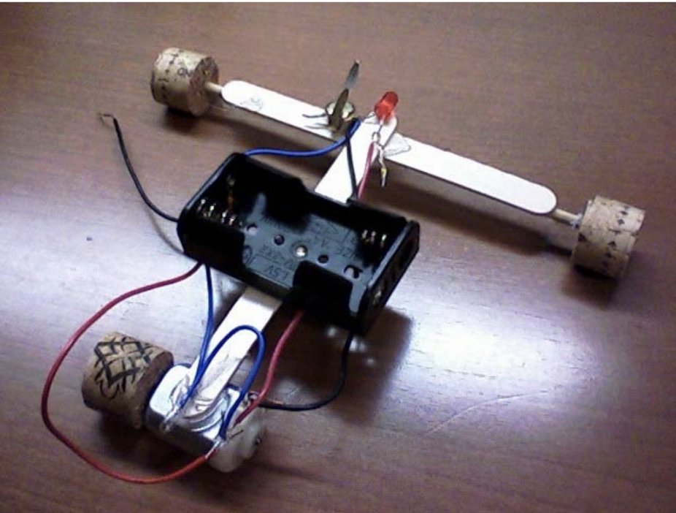

Wrap-up
End the lesson with some final discussions about what students designed/discovered. Connect their activity back to the focus question/problem, real world examples, and STEM careers.

Also include notes about any special cleanup considerations

Lesson Background for Teachers

Suggested Real-World STEM Connections
- List possible related Role Models in STEM (with details and links to more reading). Give suggestions for examples of scientists/engineers who are from underrepresented groups in STEM in related careers.
- List related real-world engineering problems and examples

Lesson Variations and Options
Include descriptions of alternative methods or ways to present things.

Explanation
Describe the background concepts and explanations behind the lesson. This can be more in depth than a teacher/instructor would actually share with students.

Key Concepts and Vocabulary
- Word 1: Grade Appropriate Definition
- Word 2: Grade Appropriate Definition

Safety Notes
- Safety instruction

